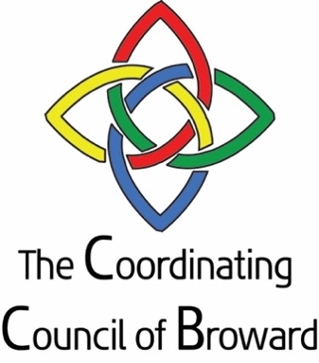

COORDINATING COUNCIL OF BROWARD COUNTY

Meeting Location:
May 4, 2022 12:00PM
Zoom Meeting

AGENDA

- Welcome Senator Nan Rich, Chair

- Chairperson update Senator Nan Rich, Chair

- Executive Director Report Sandra Veszi Einhorn

- BRHPC Presentation on Seniors Mike DeLucca and staff

- Member updates and strategic initiatives
    - Children and Families
      - ChildNet
      - Children’s Services Council
      - DCF
      - Broward County Public Schools
      - Early Learning Coalition of Broward
      - Broward Regional Health Planning Council
    - Mental Health
      - BBHC
    - Homelessness
    - Workforce Development
      - Broward College
      - CareerSource Broward
    - Aging with Dignity
      - ADRC
    - Prosperity Partnership
    - Public Safety
    - COVID

- Meeting Adjournment

Mission Statement: The mission of the Coordinating Council of Broward is to unite government, business and nonprofit leaders in advocacy and coordination of health and human services in Broward County.

Coordinating Council of Broward (CCB) is composed of the top executives of state and county entities from the public, private and business sectors, who are responsible for funding and implementing a broad array of health, public safety, education, economic and human services in Broward County. The Council’s goal is to better coordinate services and identify barriers that the ALICE (Asset Limited Income Constrained Employed) population experience. ALICE represents 47% of Broward County residents

Chair: Senator Nan Rich
Broward County Board of County Commissioners

Aging and Disability Resource Center
Charlotte Mather-Taylor, CEO

Broward Behavioral Health Coalition
Silvia Quintana, CEO

Broward College
Isabel Gonzalez, Chief of Staff; VP of Communications and Community Relations

Broward 211
Sheila Smith, CEO

Broward County
Kimm Campbell, Assistant County Administrator

Broward Health
Heather Woolf, VP of Ambulatory Services

Broward Regional Health Planning Council
Michael De Lucca, President and CEO

Broward Sheriff’s Office
Colonel Nichole Anderson, Undersheriff

Broward Workshop
Kareen Boutros, Executive Director

Career Source Broward
Carol Hylton, President

ChildNet
Larry Rein, President and CEO

Children’s Services Council
Cindy Arenberg Seltzer, President and CEO

Community Foundation of Broward
Jennifer O’Flannery Anderson, President and CEO

Department of Children & Families
Dawn Liberta, Administrator

Department of Health in Broward County
Dr. Paula Thaqi, Director

Early Learning Coalition of Broward
Renee Jaffe, President and CEO

Greater Fort Lauderdale Alliance/Six Pillars
Joseph Hovancak, Executive Director

Health Foundation of South Florida
Loreen Chant, CEO

Henderson Behavioral Health
Dr. Steven Ronik, President and CEO

Jewish Federation of Broward County
Evan Goldman, VP, Government and Community Relations
Memorial Healthcare System
Tim Curtin, Executive Director, Community Services

South Florida Regional Planning Council
Isabel Cosio Carballo, Executive Director

School Board of Broward County
John Sullivan, Chief Communications Officer
United Way of Broward County
Kathleen Cannon, Chief Executive Officer

